**WP ASSIGNMENT**

**ZWIGGY.html**

<!DOCTYPE html>

<html><head><title>**MY WEBPAGE**</title></head>

<style>

**marquee{**

**font-size:40px;**

**font-family:Comic Sans MS;**

**color:white;**

**}**

**p{**

**text-align:center;**

**font-size:40px;**

**font-family:Comic Sans MS;**

**font-weight:bold;**

**color:white;**

**}**

**body {**

**background-image: url('chilli.jpg');**

**background-repeat:no-repeat;**

**background-size:cover;**

**}**

**a {**

**text-align:center;**

**}**

**p.one{**

**text-align :center;**

**color:white;**

**font-family:Comic Sans MS;**

**border-color:yellow;**

**border-style:dashed;**

**border-radius:5px;**

**font-size:50px;**

**}**

</style>

<body>

<p class=**"one"**> **ZWIGGY** </p>

<marquee bgcolor=**"black"** height=**"60px"** scrollamount=**"30"**> **Upto 50% off !! on your first three orders..** </marquee>

<marquee scrollamount=**"30"**>

<a href=**"Burger.html"**>

<img src=**"C:\WP ASSIGNMENT\burger1.jpg"** height=**"300px"**>

</a>

<img src=**"C:\WP ASSIGNMENT\pizza.jpg"** height=**"300px"** width=**"350px"**>

<img src=**"C:\WP ASSIGNMENT\momos.jpg"** height=**"300px"** width=**"350px"**>

<img src=**"C:\WP ASSIGNMENT\paneer.jpg"** height=**"300px"** width=**"350px"**>

<img src=**"C:\WP ASSIGNMENT\biryani.jpg"** height=**"300px"** width=**"350px"**>

<img src=**"C:\WP ASSIGNMENT\chaats.jpg"** height=**"300px"** width=**"350px"**>

<img src=**"C:\WP ASSIGNMENT\wraps.jpg"** height=**"300px"** width=**"350px"**>

<img src=**"C:\WP ASSIGNMENT\ice cream.jpg"** height=**"300px"** width=**"350px"**>

<img src=**"C:\WP ASSIGNMENT\sandwich.jpg"** height=**"300px"** width=**"350px"**>

<img src=**"C:\WP ASSIGNMENT\blueberry.jpg"** height=**"300px"** width=**"350px"**>

</marquee>

<p>**Click here for Menu !!!**</p>

<a href=**"Menu.html"**><p>**Menu**</a></p>

</body>

</html>

**OUTPUT:**

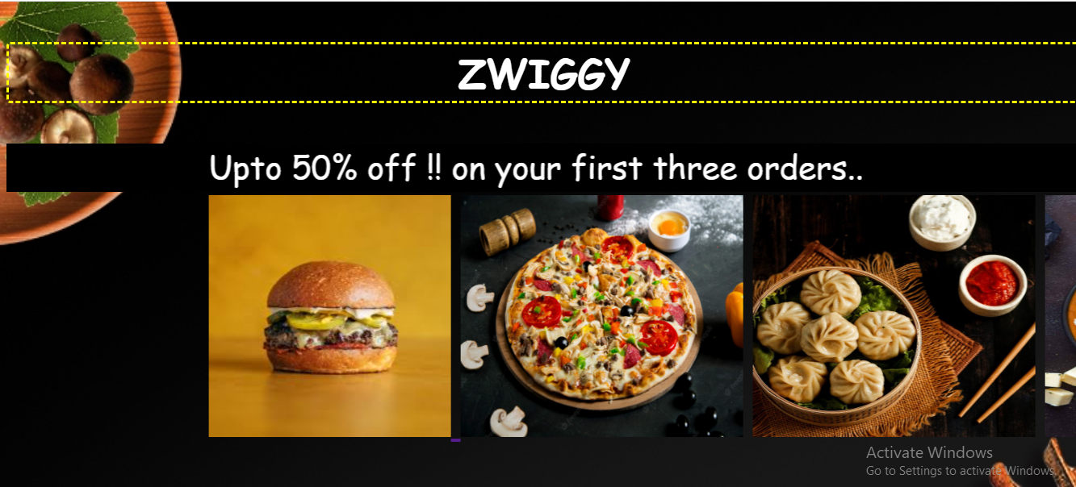

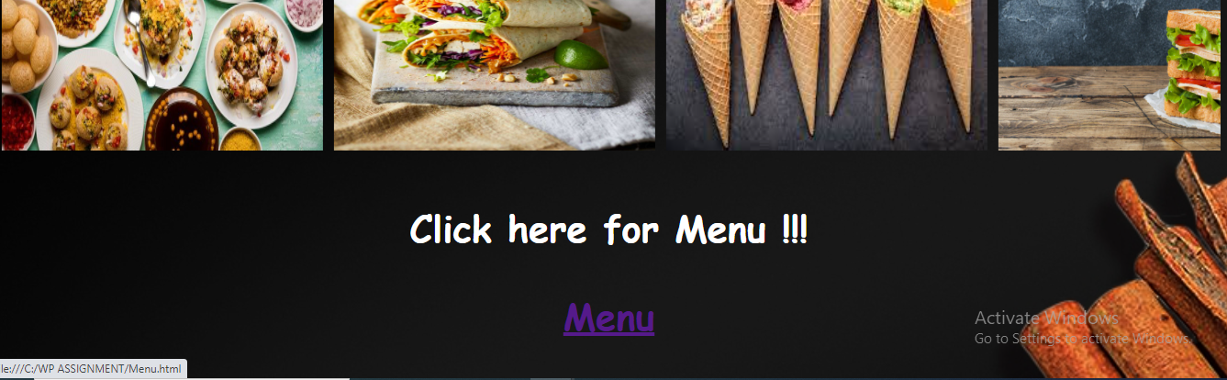

**Menu.html**

<!DOCTYPE html>

<html>

<head><title>**MENU** </title></head>

<style>

**p {**

**font-family:Comic Sans MS;**

**font-weight:bold;**

**color:white;**

**font-size:30px;**

**}**

**body{**

**background-image:url('f4back.jpg');**

**background-repeat:no-repeat;**

**background-size:cover;**

**}**

**.menu-data{**

**padding: 4rem;**

**}**

**.item p {**

**display: inline-block;**

**}**

**.dish-name{**

**text-align: left;**

**width:75%;**

**}**

**.price{**

**text-align:right;**

**}**

**button{**

**background-color:pink;**

**font-size:35px;**

**font-family:Comic Sans MS;**

**border-radius:12px;**

**}**

**img {**

**border:4px yellow solid;**

</style>

<body>

<button>

<a href=**"ZWIGGY.html"** align=**"left"**>**HOME** </a>

</button>

<h1><p align=**"center"**> **DELECIOUS MENU :**</h1></p>

<div class=**"menu-data"**>

<div class=**"item"**>

<p class=**"dish-name"**>

<a href=**"Burger.html"**>**BURGERS**</a>

</p>

<p class=**"price"**>

<img src=**"C:\WP ASSIGNMENT\burger1.jpg"** height=**"125px"** width=**"125px"**>

</p>

</div>

<div class=**"item"**>

<p class=**"dish-name"**>

<a href=**"Pizza.html"**>**PIZZA**</a>

<p class=**"price"**>

<img src=**"C:\WP ASSIGNMENT\pizza.jpg"** height=**"125px"** width=**"125px"**>

</p>

</div>

<div class=**"item"**>

<p class=**"dish-name"**>

<a href=**"Wraps.html"**>**WRAPS**</a>

<p class=**"price"**>

<img src=**"C:\WP ASSIGNMENT\wraps.jpg"** height=**"125px"** width=**"125px"** border=**"dotted"**>

</p>

</div>

<div class=**"item"**>

<p class=**"dish-name"**>

<a href=**"Momos.html"**>**MOMOS**</a>

<p class=**"price"**>

<img src=**"C:\WP ASSIGNMENT\momos.jpg"** height=**"155px"** width=**"155px"**>

</p>

</div>

<div class=**"item"**>

<p class=**"dish-name"**>

<a href=**"Chaats.html"**>**CHAATS**</a>

<p class=**"price"**>

<img src=**"C:\WP ASSIGNMENT\chaats.jpg"** height=**"125px"** width=**"150px"**>

</p>

</div>

<div class=**"item"**>

<p class=**"dish-name"**>

<a href=**"Sandwich.html"**>**SANDWICH**</a>

<p class=**"price"**>

<img src=**"C:\WP ASSIGNMENT\sandwich.jpg"** height=**"125px"** width=**"150px"**>

</p>

</div>

<div class=**"item"**>

<p class=**"dish-name"**>

<a href=**"Biryani.html"**>**BIRYANI**</a>

<p class=**"price"**>

<img src=**"C:\WP ASSIGNMENT\biryani.jpg"** height=**"125px"** width=**"175px"**>

</p>

</div>

<div class=**"item"**>

<p class=**"dish-name"**>

<a href=**"Paneer dishes.html"**>**PANEER DISHES**</a>

<p class=**"price"**>

<img src=**"C:\WP ASSIGNMENT\paneer.jpg"** height=**"125px"** width=**"165px"**>

</p>

</div>

<div class=**"item"**>

<p class=**"dish-name"**>

<a href=**"Dessert.html"**>**DESSERT**</a>

<p class=**"price"**>

<img src=**"C:\WP ASSIGNMENT\blueberry.jpg"** height=**"175px"** width=**"175px"**>

</p>

</div>

<div class=**"item"**>

<p class=**"dish-name"**>

<a href=**"Ice cream.html"**>**ICE CREAM**</a>

<p class=**"price"**>

<img src=**"C:\WP ASSIGNMENT\ice cream.jpg"** height=**"125px"** width=**"165px"**>

</p>

</div>

</body>

</html>

**OUTPUT:**

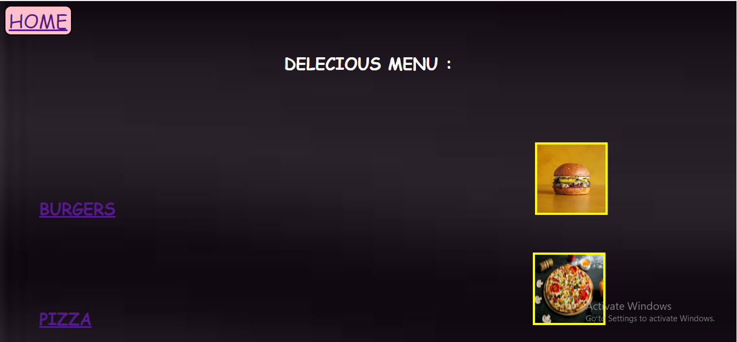

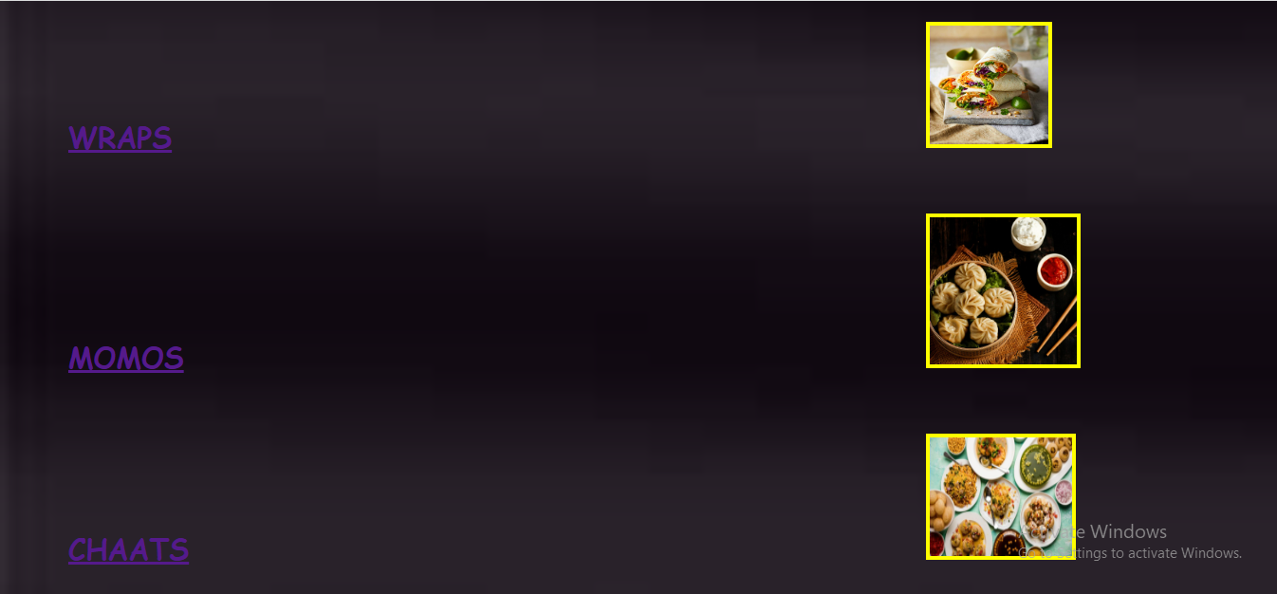

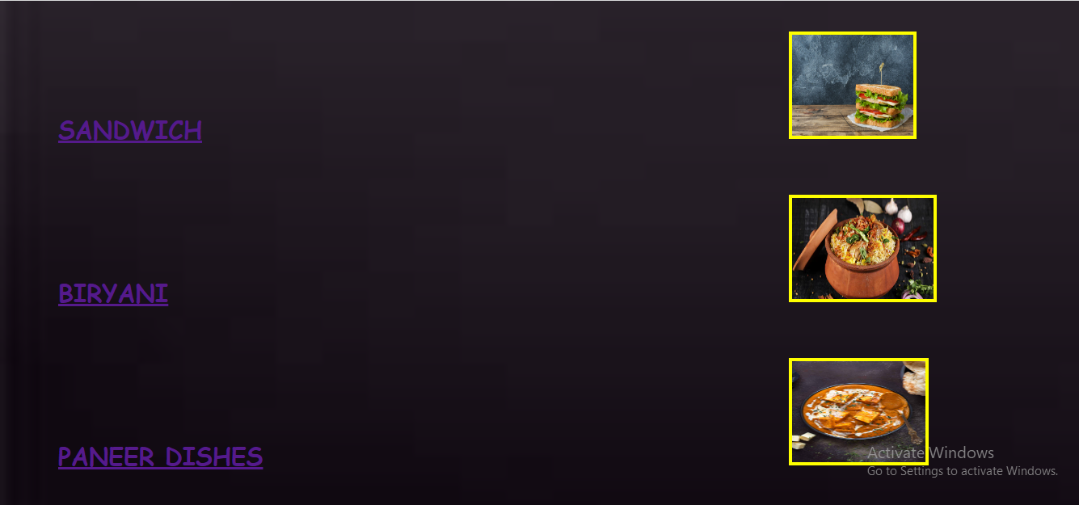

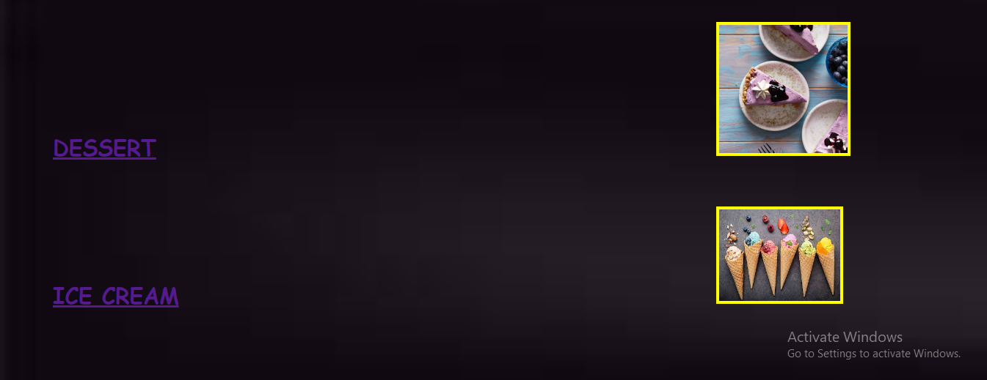

**Burger.html**

<!DOCTYPE html>

<html>

<head><title>**Burger** </title></head>

<style>

**p {**

**font-family:Comic Sans MS;**

**font-weight:bold;**

**color:black;**

**font-size:30px;**

**}**

**body{**

**background-image:url('b4back.jpg');**

**background-repeat:no-repeat;**

**background-size:cover;**

**}**

**.menu-data{**

**padding: 4rem;**

**}**

**.item p {**

**display: inline-block;**

**}**

**.dish-name{**

**text-align: left;**

**width:75%;**

**}**

**.price{**

**text-align:right;**

**}**

**button{**

**background-color:pink;**

**font-size:35px;**

**font-family:Comic Sans MS;**

**border-radius:12px;**

**}**

</style>

<body>

<button>

<a href=**"Menu.html"** align=**"right"**>**MAIN MENU** </a></button>

<h1><p align=**"center"**> **BURGER VARITIES :**</h1></p>

<div class=**"menu-data"**>

<div class=**"item"**>

<p class=**"dish-name"**>**ALOO TIKKI BURGER**</p>

<p class=**"price"**>**30**</p>

</div>

<div class=**"item"**>

<p class=**"dish-name"**>**VEG SCHEZWAN** </p>

<p class=**"price"**>**40**</p>

</div>

<div class=**"item"**>

<p class=**"dish-name"**>**PANEER BURGER**<p>

<p class=**"price"**>**60**</p>

</div>

<div class=**"item"**>

<p class=**"dish-name"**> **CHEESE VEG CRUNCH** </p>

<p class=**"price"**>**50**</p>

</div>

<div class=**"item"**>

<p class=**"dish-name"**>**CRISPY CHICKEN BURGER**</p>

<p class=**"price"**>**55**</p>

</div>

<div class=**"item"**>

<p class=**"dish-name"**>**CHICKEN CHEESE BURGER** </p>

<p class=**"price"**>**70**</p>

</div>

<div class=**"item"**>

<p class=**"dish-name"**> **SPICY MEXICAN BURGER**</p>

<p class=**"price"**>**60**</p>

</div>

<div class=**"item"**>

<p class=**"dish-name"**>**BBQ CHICKEN BURGER**</p>

<p class=**"price"**>**80**</p>

</body>

</html>

**Output:**

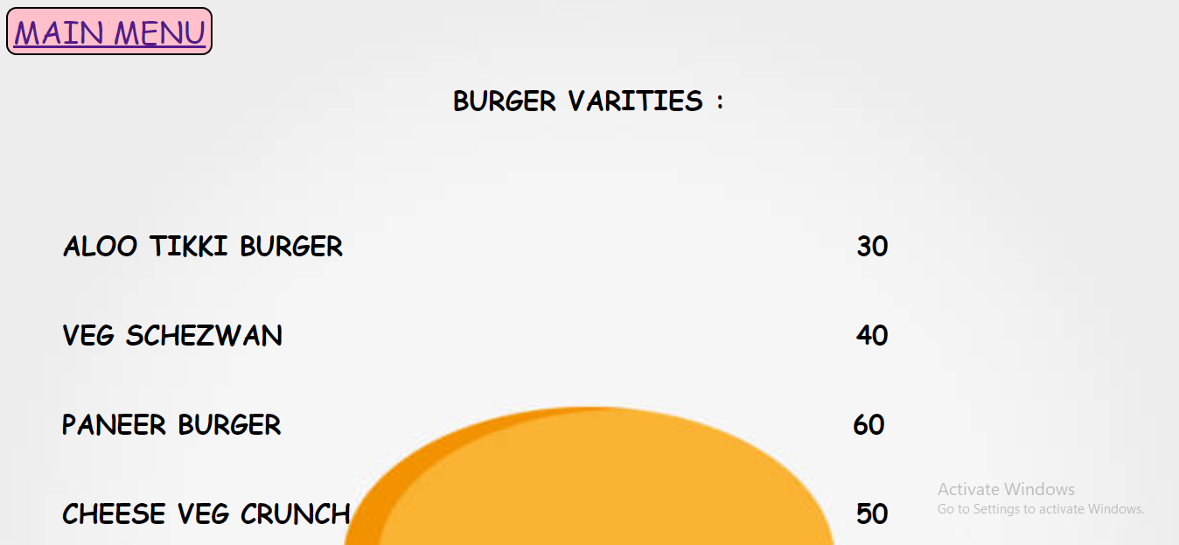

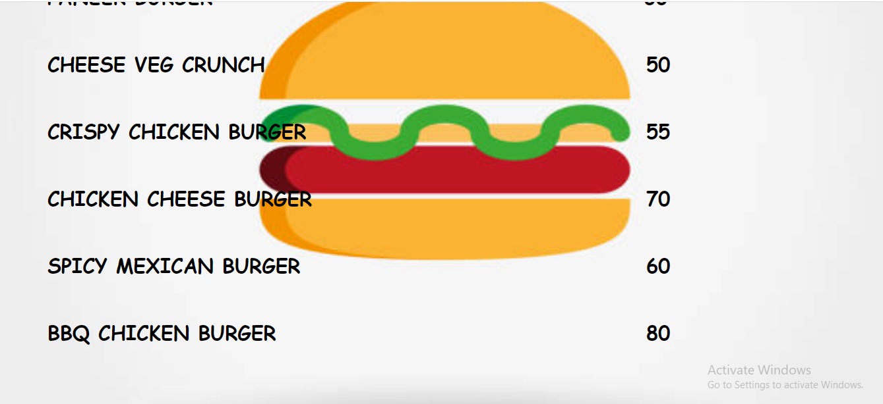

**Pizza.html**

<!DOCTYPE html>

<html>

<head><title>**Pizza**</title></head>

<style>

**p {**

**font-family:Comic Sans MS;**

**font-weight:bold;**

**color:black;**

**font-size:30px;**

**}**

**body{**

**background-image:url('piback.jpg');**

**background-repeat:no-repeat;**

**background-size:cover;**

**}**

**.menu-data{**

**padding: 4rem;**

**}**

**.item p {**

**display: inline-block;**

**}**

**.dish-name{**

**text-align: left;**

**width:75%;**

**}**

**.price{**

**text-align:right;**

**}**

**button{**

**background-color:pink;**

**font-size:35px;**

**font-family:Comic Sans MS;**

**border-radius:12px;**

**}**

</style>

<body>

<button>

<a href=**"Menu.html"** align=**"right"**>**MAIN MENU** </a></button>

<h1><p align=**"center"**> **PIZZA VARITIES :**</h1></p>

<div class=**"menu-data"**>

<div class=**"item"**>

<p class=**"dish-name"**>**MARGHERITA**</p>

<p class=**"price"**>**99**</p>

</div>

<div class=**"item"**>

<p class=**"dish-name"**> **PANEER AND ONION**</p>

<p class=**"price"**>**120**</p>

</div>

<div class=**"item"**>

<p class=**"dish-name"**>**CAPSICUM**<p>

<p class=**"price"**>**99**</p>

</div>

<div class=**"item"**>

<p class=**"dish-name"**> **VEG LOADED** </p>

<p class=**"price"**>**150**</p>

</div>

<div class=**"item"**>

<p class=**"dish-name"**>**SPICY PASTA PIZZA**</p>

<p class=**"price"**>**190**</p>

</div>

<div class=**"item"**>

<p class=**"dish-name"**>**4 CHEESE PIZZA** </p>

<p class=**"price"**>**330**</p>

</div>

<div class=**"item"**>

<p class=**"dish-name"**>**PEPPER BARBECUE CHICKEN**</p>

<p class=**"price"**>**260**</p>

</div>

<div class=**"item"**>

<p class=**"dish-name"**>**CHICKEN PEPPERONI**</p>

<p class=**"price"**>**360**</p>

</div>

<div class=**"item"**>

<p class=**"dish-name"**>**NON VEG SUPREME** </p>

<p class=**"price"**>**350**<p>

</div>

</body>

</html>

**Output:**

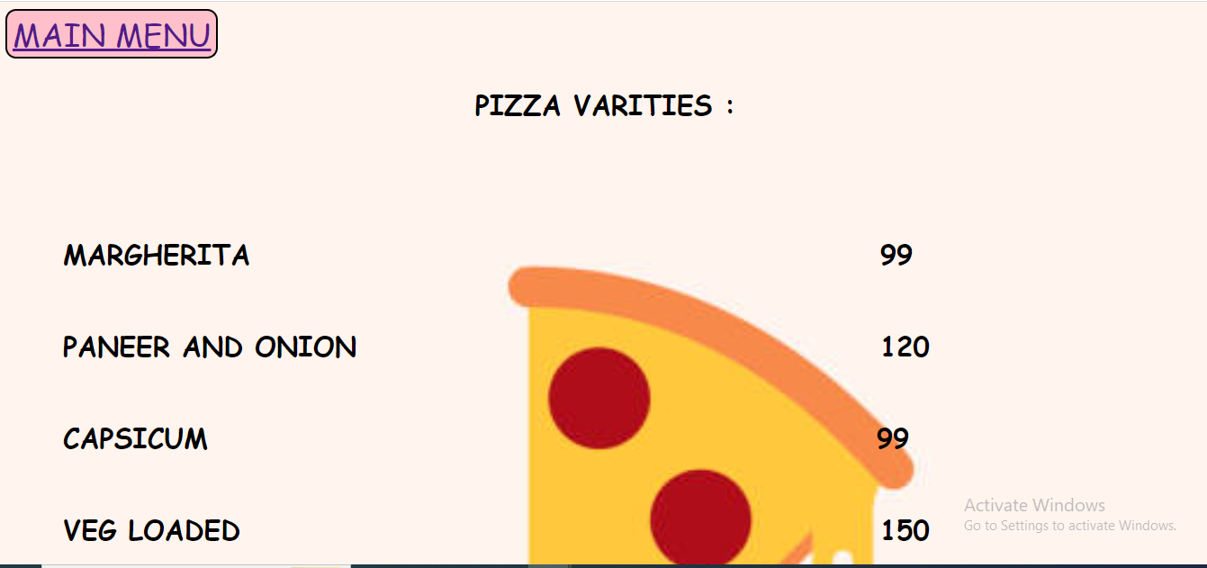

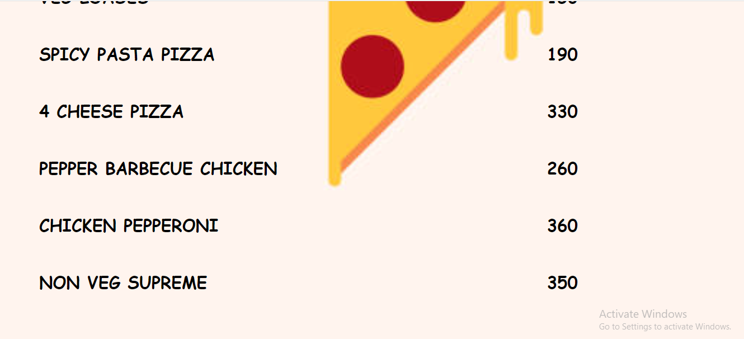

**Wraps.html**

<!DOCTYPE html>

<html>

<head><title>**Wraps**</title></head>

<style>

**p {**

**font-family:Comic Sans MS;**

**font-weight:bold;**

**color:maroon;**

**font-size:30px;**

**}**

**body{**

**background-image:url('wback.jpg');**

**background-repeat:no-repeat;**

**background-size:cover;**

**}**

**.menu-data{**

**padding: 4rem;**

**}**

**.item p {**

**display: inline-block;**

**}**

**.dish-name{**

**text-align: left;**

**width:75%;**

**}**

**.price{**

**text-align:right;**

**}**

**button{**

**background-color:pink;**

**font-size:35px;**

**font-family:Comic Sans MS;**

**border-radius:12px;**

**}**

</style>

<body>

<button>

<a href=**"Menu.html"** align=**"right"**>**MAIN MENU** </a></button>

<h1><p align=**"center"**> **WRAPS VARITIES :**</h1></p>

<div class=**"menu-data"**>

<div class=**"item"**>

<p class=**"dish-name"**>**CHEESY CORN WRAP**</p>

<p class=**"price"**>**120**</p>

</div>

<div class=**"item"**>

<p class=**"dish-name"**> **PANEER TIKKA WRAP**</p>

<p class=**"price"**>**160**</p>

</div>

<div class=**"item"**>

<p class=**"dish-name"**>**VEG FALEFAL WRAP**</p>

<p class=**"price"**>**140**</p>

</div>

<div class=**"item"**>

<p class=**"dish-name"**> **BAKED PIZZA WRAP** </p>

<p class=**"price"**> **180**</p>

</div>

<div class=**"item"**>

<p class=**"dish-name"**>**MEXICAN SALSA WRAP**</p>

<p class=**"price"**>**180**</p>

</div>

<div class=**"item"**>

<p class=**"dish-name"**>**CHICKEN TIKKA WRAP** </p>

<p class=**"price"**>**200**</p>

</div>

<div class=**"item"**>

<p class=**"dish-name"**>**CHICKEN BARBEQUE WRAP**</p>

<p class=**"price"**>**220**</p>

</div>

<div class=**"item"**>

<p class=**"dish-name"**>**CHICKEN PERI PERI WRAP**</p>

<p class=**"price"**>**250**</p>

</div>

</body>

</html>

**Output:**

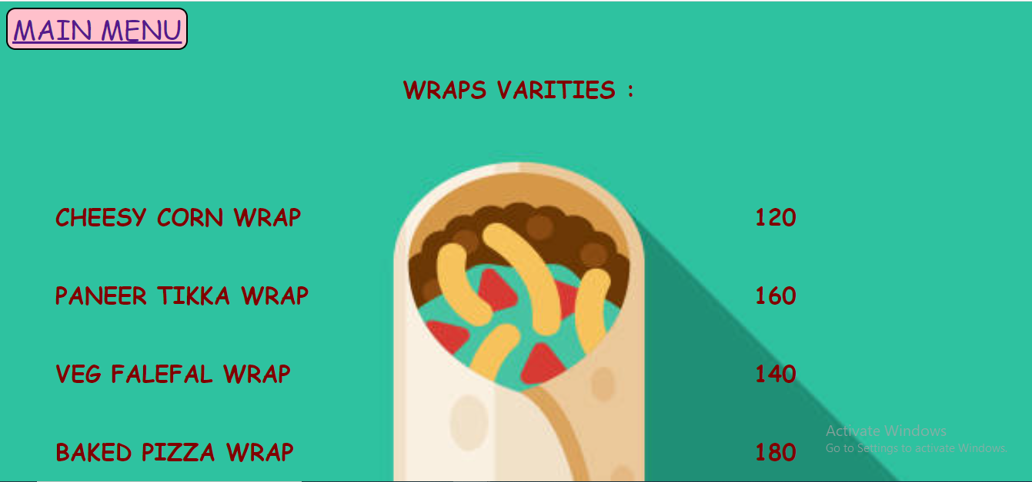

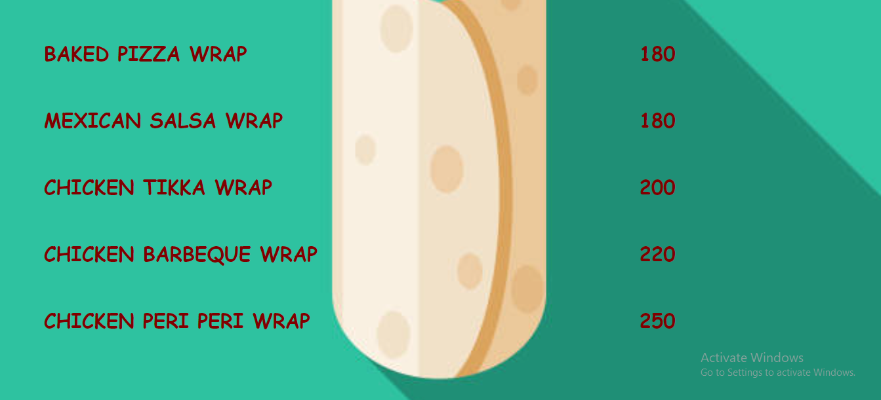

**Momos.html**

<!DOCTYPE html>

<html>

<head><title>**Momos**</title></head>

<style>

**p {**

**font-family:Comic Sans MS;**

**font-weight:bold;**

**color:red;**

**font-size:30px;**

**}**

**body{**

**background-image:url('mback.jpg');**

**background-repeat:no-repeat;**

**background-size:cover;**

**}**

**.menu-data{**

**padding: 4rem;**

**}**

**.item p {**

**display: inline-block;**

**}**

**.dish-name{**

**text-align: left;**

**width:75%;**

**}**

**.price{**

**text-align:right;**

**}**

**button{**

**background-color:pink;**

**font-size:35px;**

**font-family:Comic Sans MS;**

**border-radius:12px;**

**}**

</style>

<body>

<button>

<a href=**"Menu.html"** align=**"right"**>**MAIN MENU** </a></button>

<h1><p align=**"center"**> **MOMOS VARITIES :**</h1></p>

<div class=**"menu-data"**>

<div class=**"item"**>

<p class=**"dish-name"**>**CORN CHEESE STEAM MOMOS**</p>

<p class=**"price"**>**1O0**</p>

</div>

<div class=**"item"**>

<p class=**"dish-name"**> **PANEER STEAM MOMOS** </p>

<p class=**"price"**>**130**</p>

</div>

<div class=**"item"**>

<p class=**"dish-name"**>**VEG DARJEELING STEAM MOMOS** </p>

<p class=**"price"**>**160**</p>

</div>

<div class=**"item"**>

<p class=**"dish-name"**> **VEG CLASSIC STEAM MOMOS** </p>

<p class=**"price"**> **180**</p>

</div>

<div class=**"item"**>

<p class=**"dish-name"**>**CHICKEN DARJEELING STEAM MOMOS**</p>

<p class=**"price"**>**190**</p>

</div>

<div class=**"item"**>

<p class=**"dish-name"**>**CHICKEN CHEESE STEAM** </p>

<p class=**"price"**>**220**</p>

</div>

<div class=**"item"**>

<p class=**"dish-name"**>**CHICKEN FRIED PERI PERI MOMOS**</p>

<p class=**"price"**>**250**</p>

</div>

<div class=**"item"**>

<p class=**"dish-name"**>**CHICKEN TANDOORI MOMOS** </p>

<p class=**"price"**>**280**</p>

</div>

</body>

</html>

**Output:**

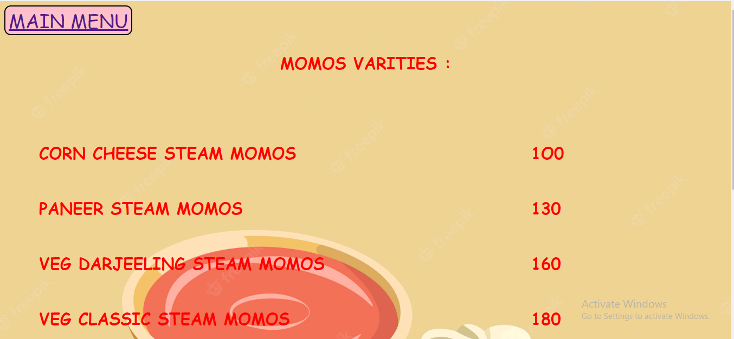

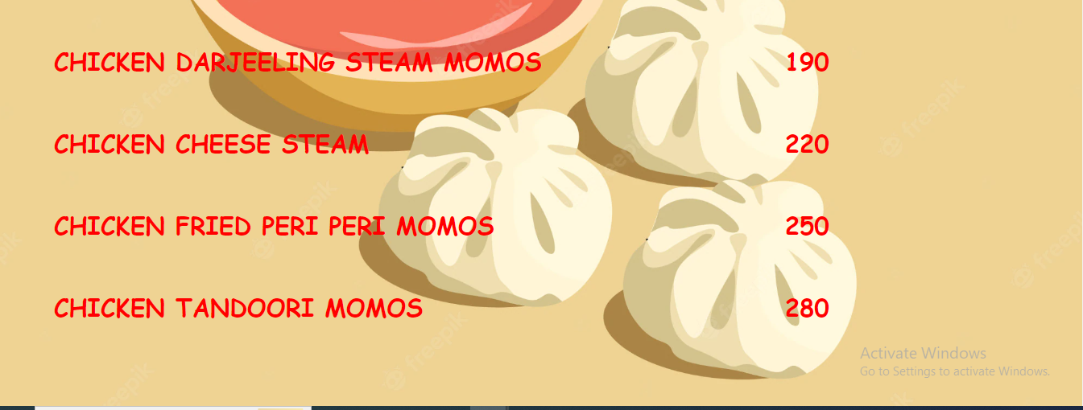

**Chaats.html**

<!DOCTYPE html>

<html>

<head><title>**Chaats**</title></head>

<style>

**p {**

**font-family:Comic Sans MS;**

**font-weight:bold;**

**color:black;**

**font-size:30px;**

**}**

**body{**

**background-image:url('ppback.jpg');**

**background-repeat:no-repeat;**

**background-size:cover;**

**}**

**.menu-data{**

**padding: 4rem;**

**}**

**.item p {**

**display: inline-block;**

**}**

**.dish-name{**

**text-align: left;**

**width:75%;**

**}**

**.price{**

**text-align:right;**

**}**

**button{**

**background-color:pink;**

**font-size:35px;**

**font-family:Comic Sans MS;**

**border-radius:12px;**

**}**

</style>

<body>

<button>

<a href=**"Menu.html"** align=**"right"**>**MAIN MENU** </a></button>

<h1><p align=**"center"**> **CHAATS VARITIES :**</h1></p>

<div class=**"menu-data"**>

<div class=**"item"**>

<p class=**"dish-name"**>**PANI PURI**</p>

<p class=**"price"**>**30**</p>

</div>

<div class=**"item"**>

<p class=**"dish-name"**> **SEV PURI** </p>

<p class=**"price"**>**30**</p>

</div>

<div class=**"item"**>

<p class=**"dish-name"**> **DAHI PURI** </p>

<p class=**"price"**>**40**</p>

</div>

<div class=**"item"**>

<p class=**"dish-name"**> **ALOO TIKKI CHAAT** </p>

<p class=**"price"**> **40**</p>

</div>

<div class=**"item"**>

<p class=**"dish-name"**>**DAHI VADA**</p>

<p class=**"price"**>**50**</p>

</div>

<div class=**"item"**>

<p class=**"dish-name"**> **VADA PAV** </p>

<p class=**"price"**>**20**</p>

</div>

<div class=**"item"**>

<p class=**"dish-name"**>**SAMOSA CHAAT**</p>

<p class=**"price"**>**40**</p>

</div>

<div class=**"item"**>

<p class=**"dish-name"**>**RAJ KACHORI** </p>

<p class=**"price"**>**50**</p>

</div>

</body>

</html>

**Output:**

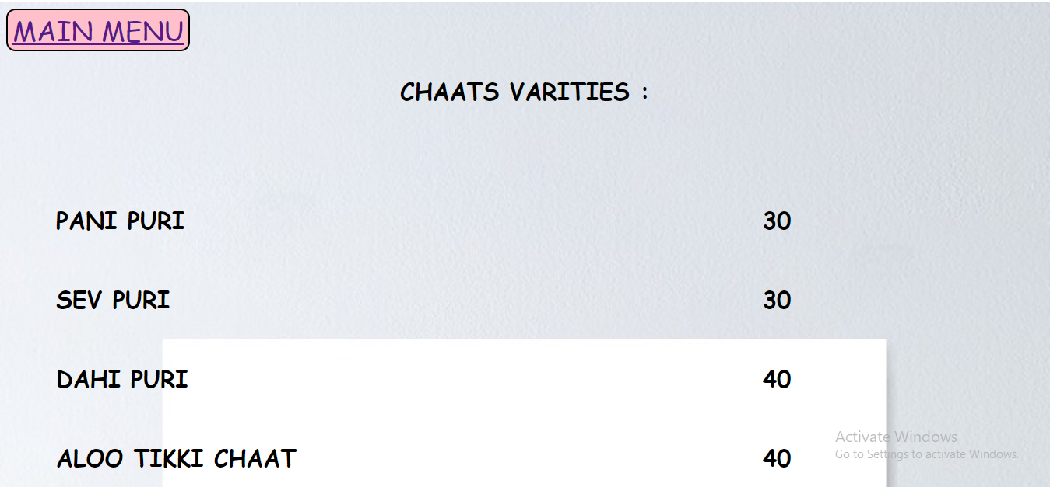

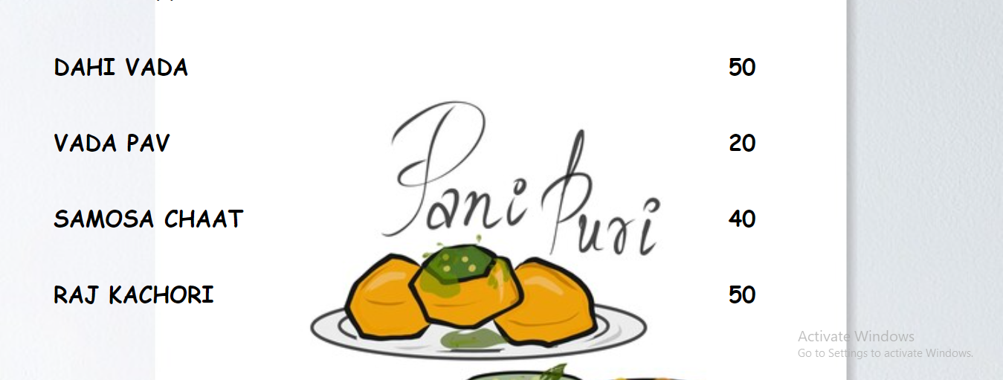

**Sandwich.html**

<!DOCTYPE html>

<html>

<head><title>**Chaats**</title></head>

<style>

**p {**

**font-family:Comic Sans MS;**

**font-weight:bold;**

**color:black;**

**font-size:30px;**

**}**

**body{**

**background-image:url('sback.jpg');**

**background-repeat:no-repeat;**

**background-size:cover;**

**}**

**.menu-data**

**{**

**padding: 4rem;**

**}**

**.item p**

**{**

**display: inline-block;**

**}**

**.dish-name**

**{**

**text-align: left;**

**width:75%;**

**}**

**.price**

**{**

**text-align:right;**

**}**

**button**

**{**

**background-color:pink;**

**font-size:35px;**

**font-family:Comic Sans MS;**

**border-radius:12px;**

**}**

</style>

<body>

<button>

<a href=**"Menu.html"** align=**"right"**>**MAIN MENU** </a></button>

<h1><p align=**"center"**> **SANDWICH VARITIES :**</h1></p>

<div class=**"menu-data"**>

<div class=**"item"**>

<p class=**"dish-name"**>**VEG GRILL SANDWICH**</p>

<p class=**"price"**>**30**</p>

</div>

<div class=**"item"**>

<p class=**"dish-name"**> **BOMBAY MASALA SANDWICH** </p>

<p class=**"price"**>**50**</p>

</div>

<div class=**"item"**>

<p class=**"dish-name"**> **PANEER GRILL SANDWICH** </p>

<p class=**"price"**>**70**</p>

</div>

<div class=**"item"**>

<p class=**"dish-name"**> **CHICKEN GRILLED SANDWICH** </p>

<p class=**"price"**> **85**</p>

</div>

<div class=**"item"**>

<p class=**"dish-name"**> **TANDOORI GRILLED SANDWICH**</p>

<p class=**"price"**>**95**</p>

</div>

<div class=**"item"**>

<p class=**"dish-name"**> **SPECIAL CLUB SANDWICH** </p>

<p class=**"price"**>**120**</p>

</div>

<div class=**"item"**>

<p class=**"dish-name"**>**CHEESY CHICKEN SANDWICH** </p>

<p class=**"price"**>**150**</p>

</div>

<div class=**"item"**>

<p class=**"dish-name"**> **BBQ CHICKEN SANDWICH** </p>

<p class=**"price"**>**170**</p>

</div>

</body>

</html>

**Output:**

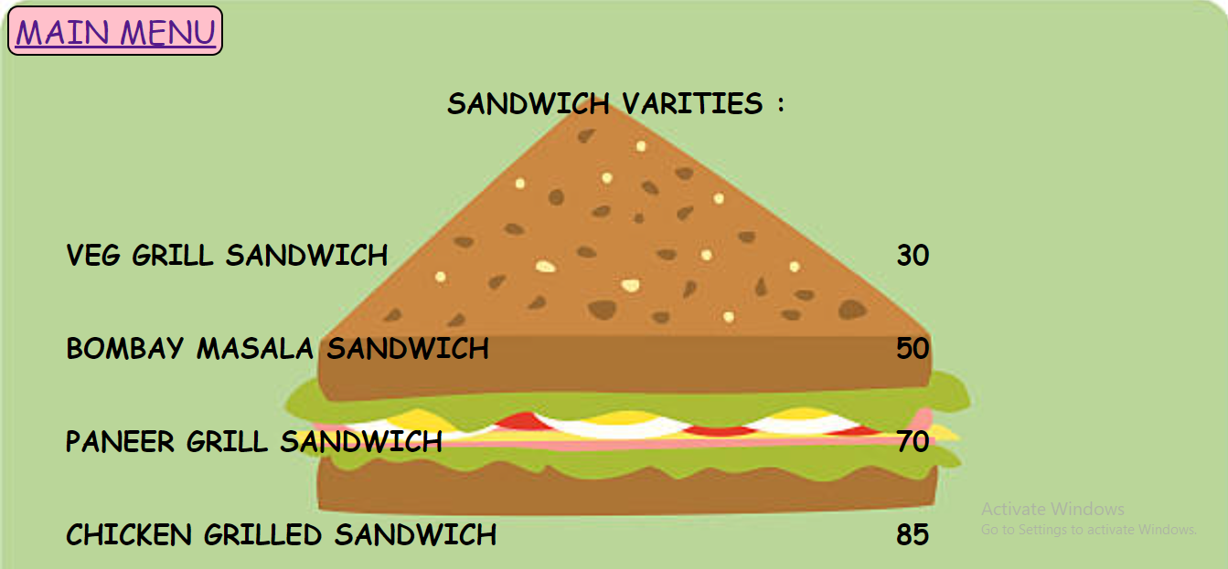

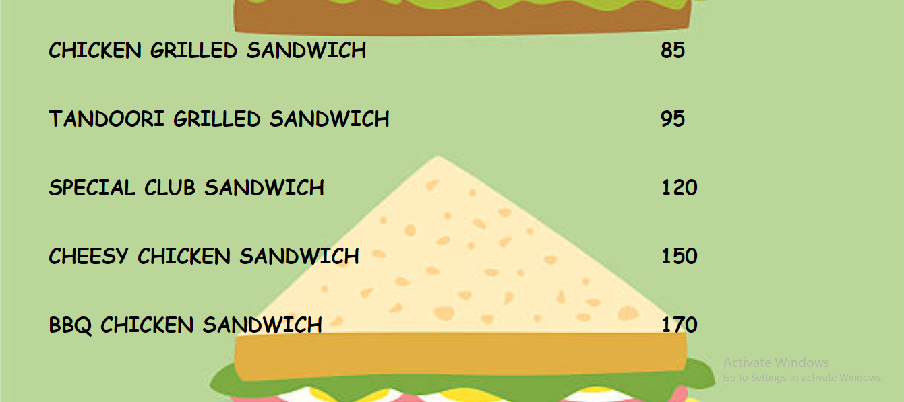

**Biryani.html**

<!DOCTYPE html>

<html>

<head><title>**Biryani**</title></head>

<style>

**p {**

**font-family:Comic Sans MS;**

**font-weight:bold;**

**color:black;**

**font-size:30px;**

**}**

**body{**

**background-image:url('bi2back.jpg');**

**background-repeat:no-repeat;**

**background-size:cover;**

**}**

**.menu-data**

**{**

**padding: 4rem;**

**}**

**.item p**

**{**

**display: inline-block;**

**}**

**.dish-name**

**{**

**text-align: left;**

**width:75%;**

**}**

**.price**

**{**

**text-align:right;**

**}**

**button**

**{**

**background-color:pink;**

**font-size:35px;**

**font-family:Comic Sans MS;**

**border-radius:12px;**

**}**

</style>

<body>

<button>

<a href=**"Menu.html"** align=**"right"**>**MAIN MENU** </a></button>

<h1><p align=**"center"**> **BIRYANI VARITIES :**</h1></p>

<div class=**"menu-data"**>

<div class=**"item"**>

<p class=**"dish-name"**>**VEG BIRYANI** </p>

<p class=**"price"**>**200**</p>

</div>

<div class=**"item"**>

<p class=**"dish-name"**> **CHICKEN BIRYANI** </p>

<p class=**"price"**>**250**</p>

</div>

<div class=**"item"**>

<p class=**"dish-name"**> **HYDERABADI BIRYANI** </p>

<p class=**"price"**>**350**</p>

</div>

<div class=**"item"**>

<p class=**"dish-name"**> **CHICKEN TIKKA BIRYANI** </p>

<p class=**"price"**> **300**</p>

</div>

<div class=**"item"**>

<p class=**"dish-name"**> **CHICKEN SEEKH BIRYANI**</p>

<p class=**"price"**>**400**</p>

</div>

<div class=**"item"**>

<p class=**"dish-name"**> **PANEER MAKHNI BIRYANI** </p>

<p class=**"price"**>**380**</p>

</div>

<div class=**"item"**>

<p class=**"dish-name"**> **AFGHANI TIKKA BIRYANI**</p>

<p class=**"price"**>**450**</p>

</div>

<div class=**"item"**>

<p class=**"dish-name"**> **TANDOORI DUM BIRYANI** </p>

<p class=**"price"**>**350**</p>

</div>

</body>

</html>

**Output:**

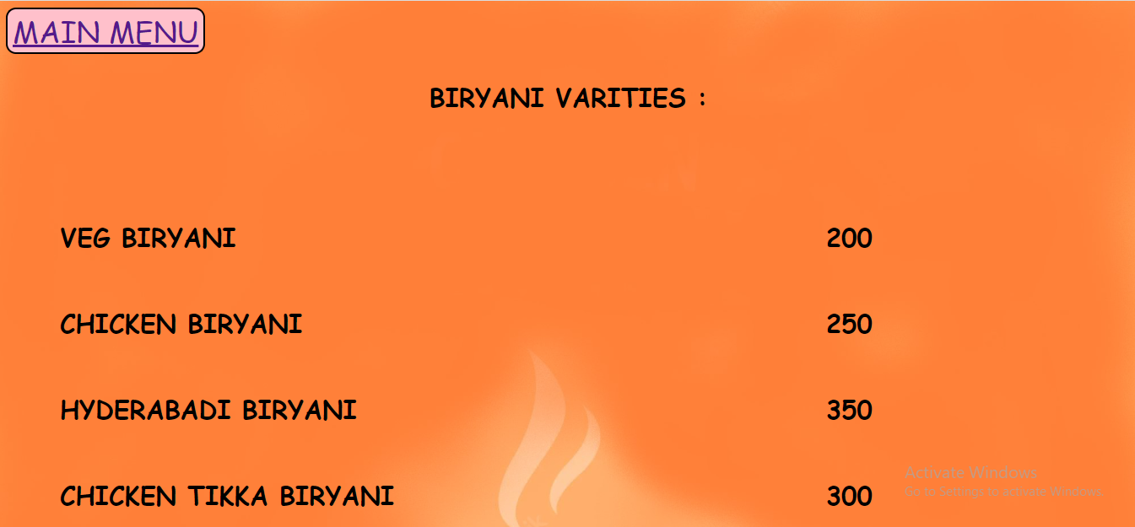

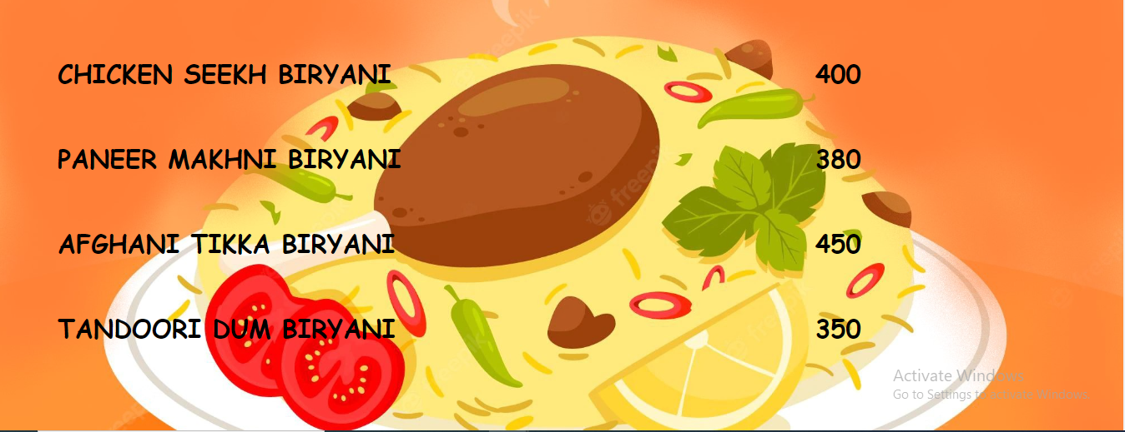

**Paneer dishes.html**

<!DOCTYPE html>

<html>

<head><title>**Paneer**</title></head>

<style>

**p {**

**font-family:Comic Sans MS;**

**font-weight:bold;**

**color:black;**

**font-size:30px;**

**}**

**body{**

**background-image:url('pa5back.jpg');**

**background-repeat:no-repeat;**

**background-size:cover;**

**}**

**.menu-data**

**{**

**padding: 4rem;**

**}**

**.item p**

**{**

**display: inline-block;**

**}**

**.dish-name**

**{**

**text-align: left;**

**width:75%;**

**}**

**.price**

**{**

**text-align:right;**

**}**

**button**

**{**

**background-color:pink;**

**font-size:35px;**

**font-family:Comic Sans MS;**

**border-radius:12px;**

**}**

</style>

<body>

<button>

<a href=**"Menu.html"** align=**"right"**>**MAIN MENU** </a></button>

<h1><p align=**"center"**> **PANEER DISHES VARITIES :**</h1></p>

<div class=**"menu-data"**>

<div class=**"item"**>

<p class=**"dish-name"**> **SHAHI MUGHLAI PANEER**</p>

<p class=**"price"**>**200**</p>

</div>

<div class=**"item"**>

<p class=**"dish-name"**> **MUTTER PANEER** </p>

<p class=**"price"**>**200**</p>

</div>

<div class=**"item"**>

<p class=**"dish-name"**> **PANEER BUTTER MASALA** </p>

<p class=**"price"**>**250**</p>

</div>

<div class=**"item"**>

<p class=**"dish-name"**> **PANEER TIKKA MASALA** </p>

<p class=**"price"**> **270**</p>

</div>

<div class=**"item"**>

<p class=**"dish-name"**> **KADHAI PANEER**</p>

<p class=**"price"**>**300**</p>

</div>

<div class=**"item"**>

<p class=**"dish-name"**> **PANEER MAKHNI** </p>

<p class=**"price"**>**320**</p>

</div>

<div class=**"item"**>

<p class=**"dish-name"**> **PANEER PASANDA**</p>

<p class=**"price"**>**350**</p>

</div>

<div class=**"item"**>

<p class=**"dish-name"**> **PALAK PANEER** </p>

<p class=**"price"**>**350**</p>

</div>

</body>

</html>

**Output:**

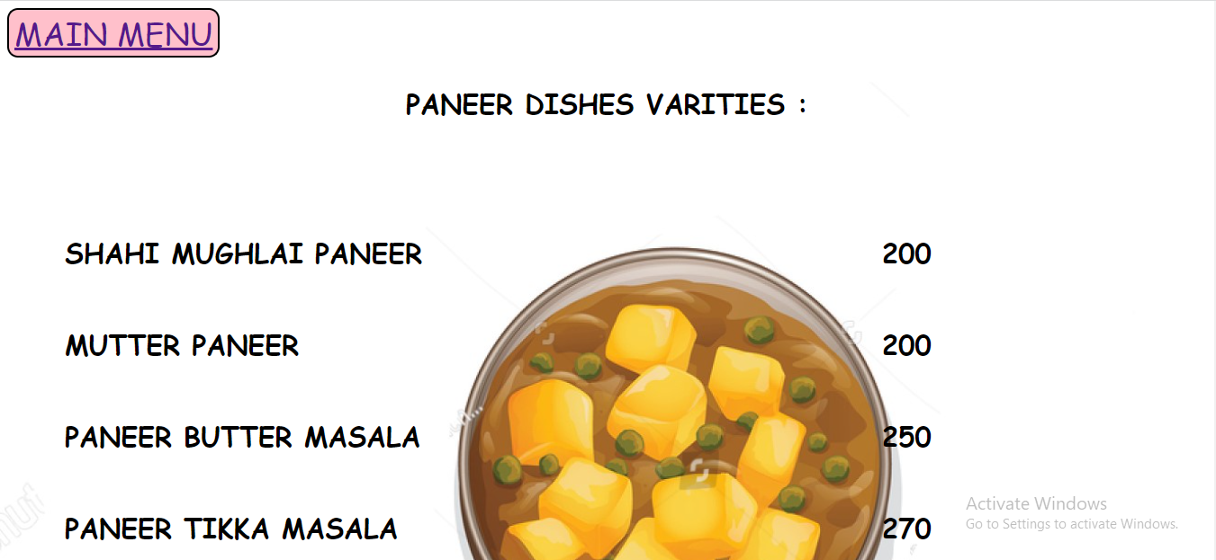

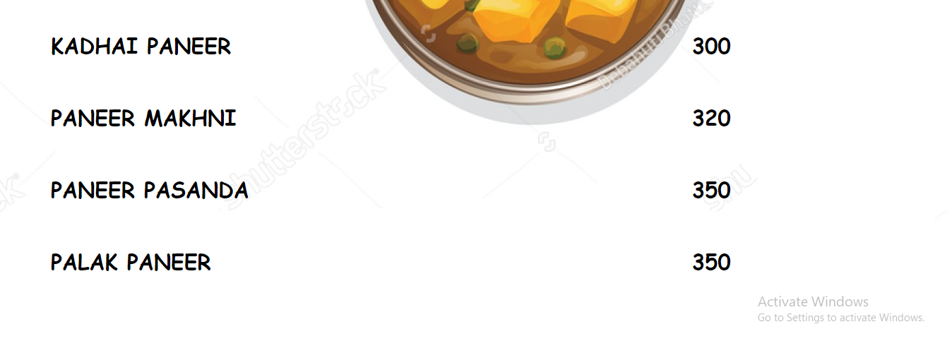

**Dessert.html**

<!DOCTYPE html>

<html>

<head><title>**Dessert**</title></head>

<style>

**p {**

**font-family:Comic Sans MS;**

**font-weight:bold;**

**color:black;**

**font-size:30px;**

**}**

**body{**

**background-image:url('cback.jpg');**

**background-repeat:no-repeat;**

**background-size:cover;**

**}**

**.menu-data**

**{**

**padding: 4rem;**

**}**

**.item p**

**{**

**display: inline-block;**

**}**

**.dish-name**

**{**

**text-align: left;**

**width:75%;**

**}**

**.price**

**{**

**text-align:right;**

**}**

**button**

**{**

**background-color:pink;**

**font-size:35px;**

**font-family:Comic Sans MS;**

**border-radius:12px;**

**}**

</style>

<body>

<button>

<a href=**"Menu.html"** align=**"right"**>**MAIN MENU** </a></button>

<h1><p align=**"center"**> **DESSERT VARITIES :**</h1></p>

<div class=**"menu-data"**>

<div class=**"item"**>

<p class=**"dish-name"**> **NUTEELA BROWNIE**</p>

<p class=**"price"**>**100**</p>

</div>

<div class=**"item"**>

<p class=**"dish-name"**> **HOT FUDGE BROWNIE WITH ICE CREAM** </p>

<p class=**"price"**>**250**</p>

</div>

<div class=**"item"**>

<p class=**"dish-name"**> **RED VELVET CHEESECAKE** </p>

<p class=**"price"**>**250**</p>

</div>

<div class=**"item"**>

<p class=**"dish-name"**> **BLUEBERRY CHEESECAKE** </p>

<p class=**"price"**> **290**</p>

</div>

<div class=**"item"**>

<p class=**"dish-name"**> **NUTELLA MOUSSE**</p>

<p class=**"price"**>**200**</p>

</div>

<div class=**"item"**>

<p class=**"dish-name"**> **BLACK FOREST DONUT** </p>

<p class=**"price"**>**140**</p>

</div>

<div class=**"item"**>

<p class=**"dish-name"**> **KIWI CREAM CHEESE DONUT**</p>

<p class=**"price"**>**200**</p>

</div>

<div class=**"item"**>

<p class=**"dish-name"**>**DARK CHOCLATE CHURROS** </p>

<p class=**"price"**>**200**</p>

</div>

</body>

</html>

**Output:**

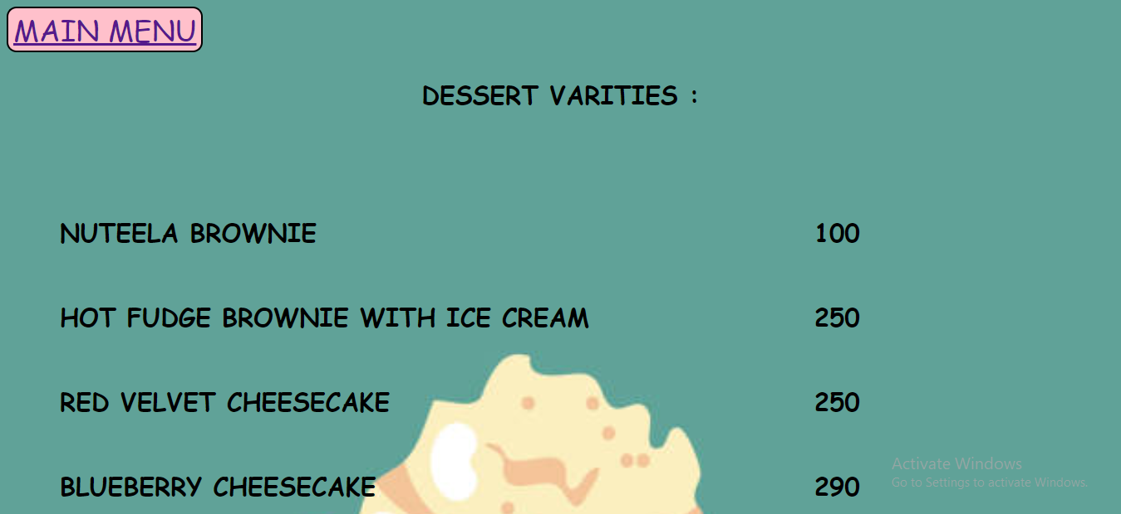

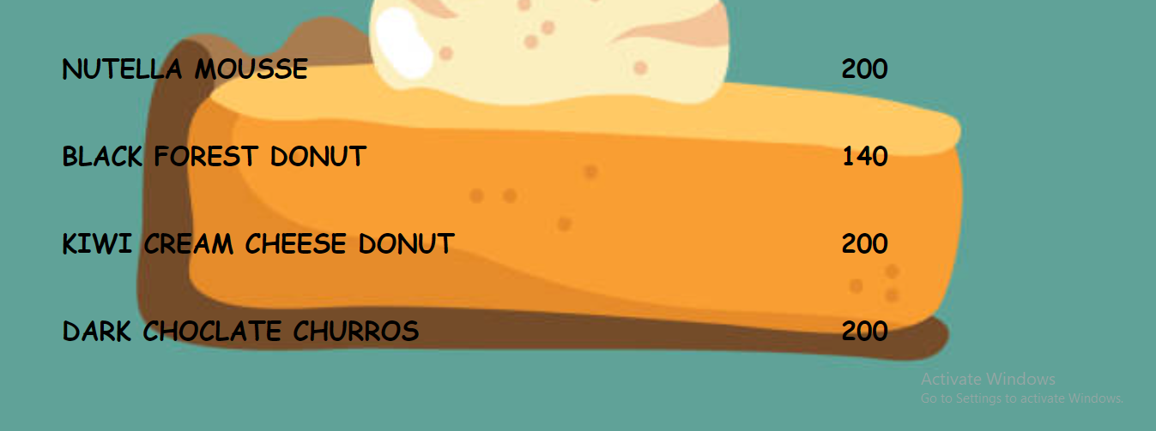

**Ice cream.html**

<!DOCTYPE html>

<html>

<head><title>**Dessert**</title></head>

<style>

**p {**

**font-family:Comic Sans MS;**

**font-weight:bold;**

**color:dark pink;**

**font-size:30px;**

**}**

**body{**

**background-image:url('iback.jpg');**

**background-repeat:no-repeat;**

**background-size:cover;**

**}**

**.menu-data**

**{**

**padding: 4rem;**

**}**

**.item p**

**{**

**display: inline-block;**

**}**

**.dish-name**

**{**

**text-align: left;**

**width:75%;**

**}**

**.price**

**{**

**text-align:right;**

**}**

**button**

**{**

**background-color:pink;**

**font-size:35px;**

**font-family:Comic Sans MS;**

**border-radius:12px;**

**}**

</style>

<body>

<button>

<a href=**"Menu.html"** align=**"right"**>**MAIN MENU** </a></button>

<h1><p align=**"center"**> **ICE CREAM VARITIES :**</h1></p>

<div class=**"menu-data"**>

<div class=**"item"**>

<p class=**"dish-name"**> **CHOCOLATE** </p>

<p class=**"price"**>**50**</p>

</div>

<div class=**"item"**>

<p class=**"dish-name"**> **VANILLA** </p>

<p class=**"price"**>**50**</p>

</div>

<div class=**"item"**>

<p class=**"dish-name"**> **STRAWBERRY** </p>

<p class=**"price"**>**60**</p>

</div>

<div class=**"item"**>

<p class=**"dish-name"**> **BLACK CURRENT** </p>

<p class=**"price"**> **90**</p>

</div>

<div class=**"item"**>

<p class=**"dish-name"**> **MANGO**</p>

<p class=**"price"**>**70**</p>

</div>

<div class=**"item"**>

<p class=**"dish-name"**> **ROASTED ALMOND**</p>

<p class=**"price"**>**100**</p>

</div>

<div class=**"item"**>

<p class=**"dish-name"**> **ANJEER**</p>

<p class=**"price"**>**100**</p>

</div>

<div class=**"item"**>

<p class=**"dish-name"**> **SITAPHAL** </p>

<p class=**"price"**>**80**</p>

</div>

</body>

</html>

**Output:**

